On-Premises Infrastructure

🏢 What Is On-Premises Infrastructure?
# Source: AI Source: Provided by: [Data Path: Persons Table -> ID Column: 1, Name_En Column: Motasem Essam] -> From: [ChatGPT] on [1/26/2026]
On-premises infrastructure (or on-prem) refers to IT hardware and software resources that are physically located and managed within an organization’s own facilities, rather than being hosted by a third-party provider like a cloud service.

🧠 Simple Definition:
# Source: AI Source: Provided by: [Data Path: Persons Table -> ID Column: 1, Name_En Column: Motasem Essam] -> From: [ChatGPT] on [1/26/2026]
On-premises infrastructure means your servers, networking equipment, storage, and software are owned, installed, and maintained on your company's site (in a data center or server room).

🧰 Components of On-Premises Infrastructure
# Source: AI Source: Provided by: [Data Path: Persons Table -> ID Column: 1, Name_En Column: Motasem Essam] -> From: [ChatGPT] on [1/26/2026]
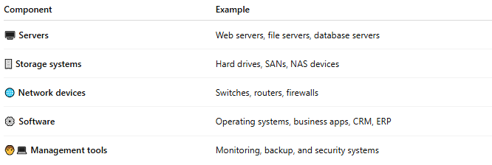
Component | Example
🖥️ Servers | Web servers, file servers, database servers
🗄️ Storage systems | Hard drives, SANs, NAS devices
🌐 Network devices | Switches, routers, firewalls
⚙️ Software | Operating systems, business apps, CRM, ERP
🧑‍💻 Management tools | Monitoring, backup, and security systems

🔒 Key Characteristics
# Source: AI Source: Provided by: [Data Path: Persons Table -> ID Column: 1, Name_En Column: Motasem Essam] -> From: [ChatGPT] on [1/26/2026]
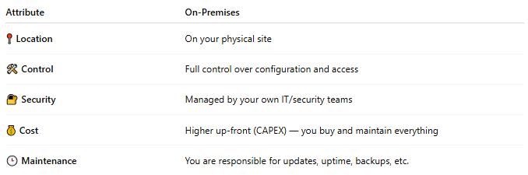
Attribute | On-Premises
📍 Location | On your physical site
🛠 Control | Full control over configuration and access
🔐 Security | Managed by your own IT/security teams
💰 Cost | Higher up-front (CAPEX) — you buy and maintain everything
🕒 Maintenance | You are responsible for updates, uptime, backups, etc.

📦 Benefits
# Source: AI Source: Provided by: [Data Path: Persons Table -> ID Column: 1, Name_En Column: Motasem Essam] -> From: [ChatGPT] on [1/26/2026]
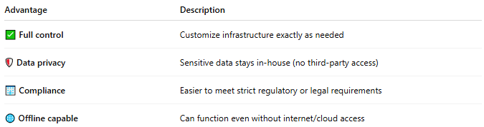
Advantage | Description
✅ Full control | Customize infrastructure exactly as needed
🛡 Data privacy | Sensitive data stays in-house (no third-party access)
🏢 Compliance | Easier to meet strict regulatory or legal requirements
🌐 Offline capable | Can function even without internet/cloud access

⚠️ Challenges
# Source: AI Source: Provided by: [Data Path: Persons Table -> ID Column: 1, Name_En Column: Motasem Essam] -> From: [ChatGPT] on [1/26/2026]
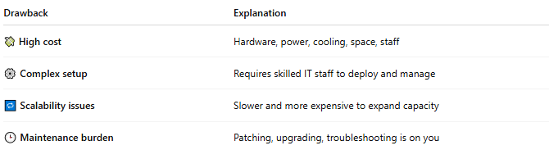
Drawback | Explanation
💸 High cost | Hardware, power, cooling, space, staff
⚙️ Complex setup | Requires skilled IT staff to deploy and manage
🔁 Scalability issues | Slower and more expensive to expand capacity
🕒 Maintenance burden | Patching, upgrading, troubleshooting is on you

🆚 On-Prem vs Cloud (Quick Comparison)
# Source: AI Source: Provided by: [Data Path: Persons Table -> ID Column: 1, Name_En Column: Motasem Essam] -> From: [ChatGPT] on [1/26/2026]
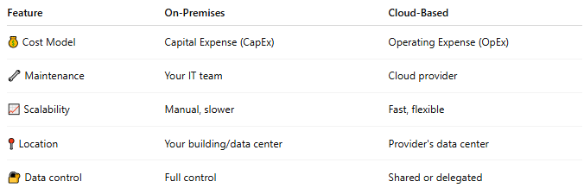
Feature | On-Premises | Cloud-Based
💰 Cost Model | Capital Expense (CapEx) | Operating Expense (OpEx)
🔧 Maintenance | Your IT team | Cloud provider
📈 Scalability | Manual, slower | Fast, flexible
📍 Location | Your building/data center | Provider's data center
🔐 Data control | Full control | Shared or delegated

📌 Summary
# Source: AI Source: Provided by: [Data Path: Persons Table -> ID Column: 1, Name_En Column: Motasem Essam] -> From: [ChatGPT] on [1/26/2026]
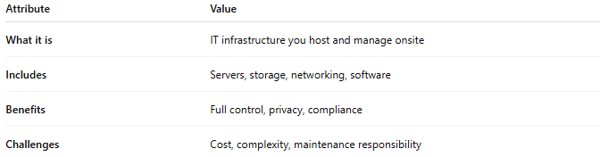
Attribute | Value
What it is | IT infrastructure you host and manage onsite
Includes | Servers, storage, networking, software
Benefits | Full control, privacy, compliance
Challenges | Cost, complexity, maintenance responsibility

